**Project Design Phase-II**

**Technology Stack (Architecture & Stack)**

|  |  |
| --- | --- |
| Date | 17 October 2022 |
| Team ID | PNT2022TMID27409 |
| Project Name | Project - Global Sales Data Analytics |
| Maximum Marks | 4 Marks |

**Technical Architecture:**

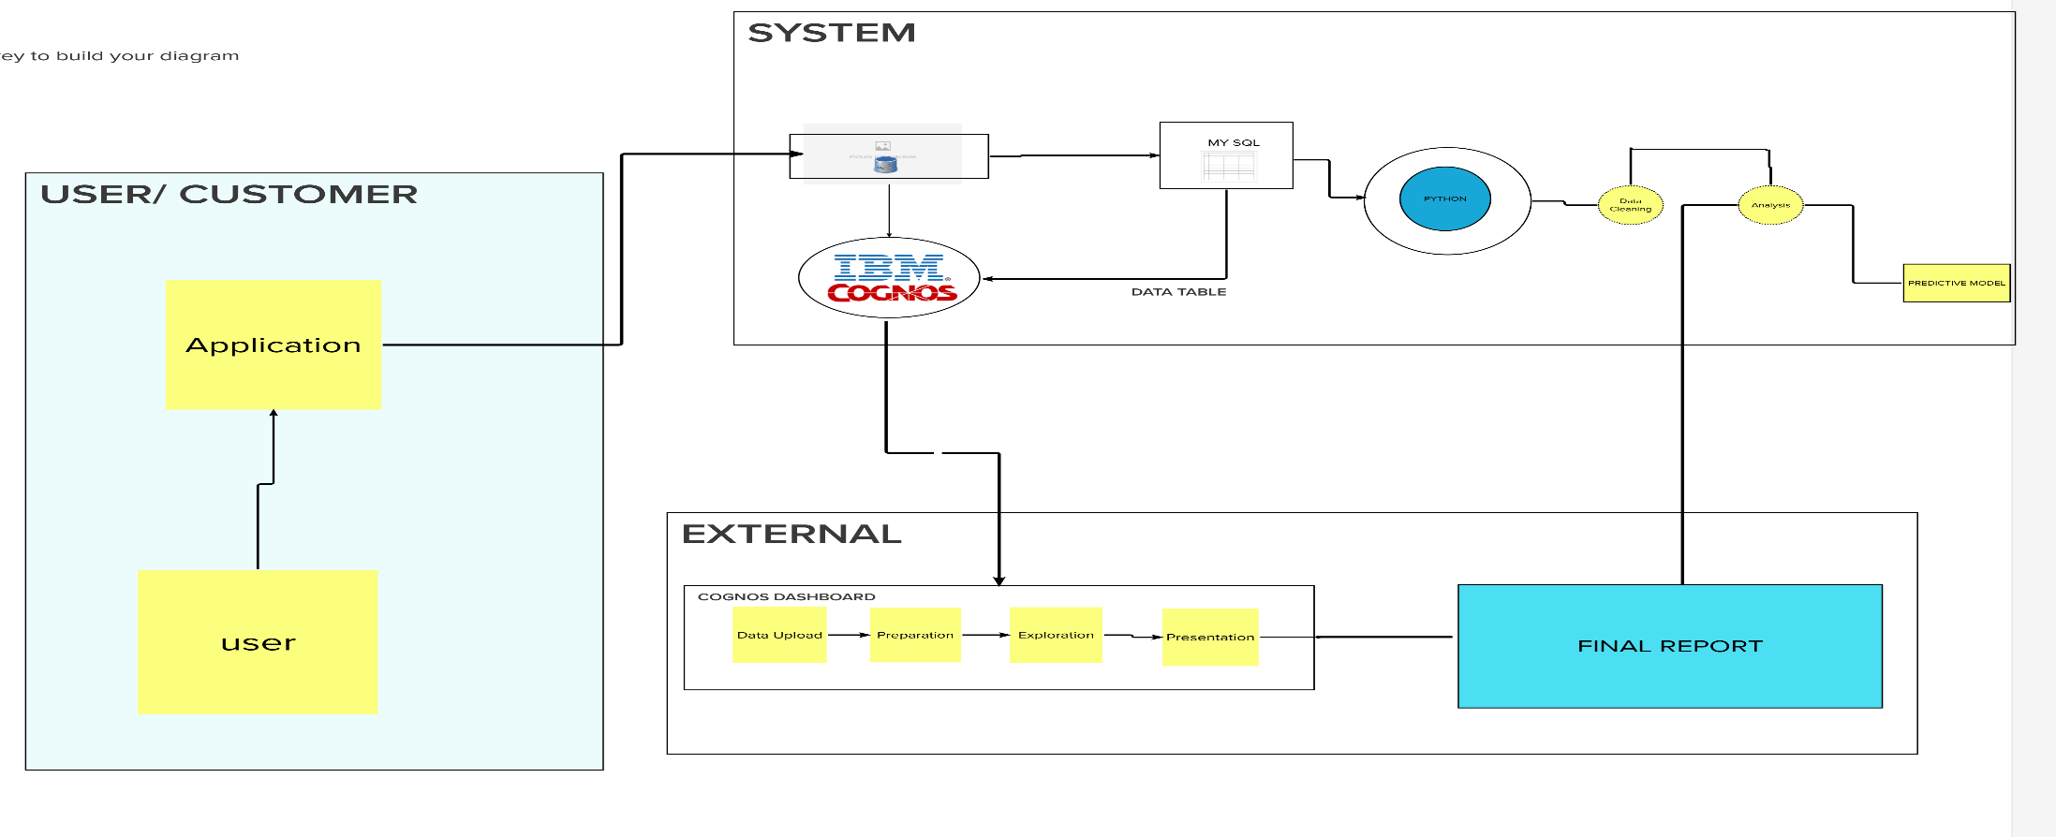

**Table-1 : Components & Technologies:**

|  |  |  |  |
| --- | --- | --- | --- |
| **S. No** | **Component** | **Description** | **Technology** |
|  | User Interface | How user interacts with application e.g.  Web UI, Mobile App, Chatbot etc. | IBM Cognos |
|  | Storage Infrastructure (Cloud) | Customer sales data is uploaded in cloud through  interface | IBM Cloud |
|  | Working with Dataset | Uploading, Cleaning and Processing dataset | IBM Cognos + IBM Cloud |
|  | Data Exploration | Uploaded data is explored to identify trends | IBM Cognos |
|  | Data Visualization | Multiple types of graphs are shown according to  customer data and requirements | IBM Cognos Dashboard |
|  | Cloud Database | Database Service on Cloud | IBM DB2, IBM Cloudetc. |
|  | Viewing Data | User logins to application to view visualizations for  uploaded data | IBM Cognos Dashboard |

**Table-2: Application Characteristics:**

| **S. No** | **Characteristics** | **Description** | **Technology** |
| --- | --- | --- | --- |
|  | Open-Source Frameworks | List the open-source frameworks used | IBM Cognos, IBM Cloud, IBM Watson |
|  | Security Implementations | Secure user information and data | e.g. SHA-256, Encryptions, IAM Controls, OWASP etc. |
|  | Scalable Architecture | Supports various data sizes | MS Excel Data set, Kaggle, Google  drive |
|  | Availability | Multi page layout providing various visualizations  of data and provide full support irrespective of  platform and device specifications | IBM cognos analytics |
|  | Performance | Withstand huge data and process them without  crashing | Presenting Visualization , Data story in  IBM cognos analytics |